20 Habits of Great Swimmers
2 Olivier Poirier-Leroy | September 25th, 2013 | Categories: Featured, Lifestyle, Training
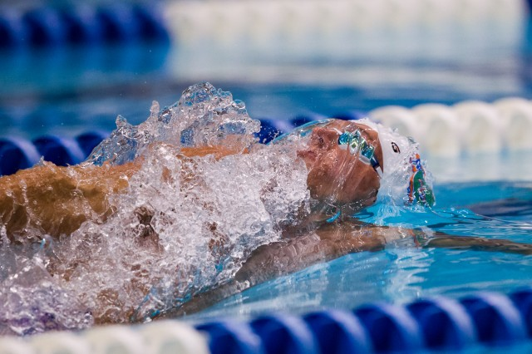
Olympic swimmers like Ryan Lochte recognize the value and results that comes with hard work. Here are 19 other habits of top-level swimmers. Photo Source: Tim Binning/TheSwimPictures.com
While there isn’t an exact formula for success that can be applied to everyone, there are some typical traits and habits of those who have achieved success in swimming that are universal.
Make 2013/2014 your best year of swimming yet by embracing some of the following habits of great swimmers:
1. They Don’t Allow Others to Dictate What They Are Capable Of. There really isn’t much more discouraging than someone you respect, admire or love telling you that your goal or dream is out of your reach, not within your abilities, or outside of the scope of your talent. Some people take this to heart, while others use it as jet fuel to light their motivation.
2. Be About It. Everyone wants to be successful; everyone talks about how they want to achieve so-and-so a time, or qualify for XYZ team. Talking about it is the easy part. But successful swimmers don’t stop at wanting or talking about it; they put words into action. You can say that you want to be a championship caliber athlete all you want, but are your actions reflecting this intent?
3. Being Great Isn’t a Part Time Gig. You can’t be good and expect to be great. Likewise, you can’t be great once in a while, or part time. Great swimmers show up every day, not when they feel like it, or when circumstances suit them.
4. The Journey is What Makes You Great. Setting goals, and chasing them is about so much more than the final result, time or placing. The journey is what creates the great swimmer, the final results are merely a symptom of what a swimmer has become by putting in work every day.
5. Great Swimmers Have Unshakable Personal Integrity. How often do you commit to something and find that within a few days or weeks your resolve loosens, until the promise you made to yourself is broken and gone? Having personal integrity means that you not only keep your word and promises with others, but most importantly that you keep your word with yourself.
6. Embrace the Grind. Sure, it would be great if life came without friction. If things went according to plan and according to our wishes all of the time. In reality we both know this is not how things go down. Setbacks, detours and roadblocks will happen, and the choice is whether they are going to be exercises in character development or the reasons for quitting.
7. Unafraid to Plan. Success isn’t an accident; it’s the result of planning combined with focused action. Great swimmers know to get to where they want to go they need to have a road map.
8. Look for Solutions, Not Excuses. While many swimmers will talk about achey muscles, excessive homework, or how they don’t feel up their best, your friendly neighborhood elite swimmer will find a way to be successful in spite of these same types of challenges.
9. Surround Themselves with Like Minded Athletes. How we perform is a result of the environment and the people we decide to surround ourselves with. Hanging out with naysayers and toxic people will rub off on us. Similarly, hanging out with athletes who are down to take things to the next level will only embolden and empower you.
10. Proactive. Great swimmers take action before need necessitates it. They don’t want for things to happen to them; they go out and make it happen for themselves. They don’t hope for success to stumble upon them via luck or good fortune; they actively chase it.
11. Willing to Go the Extra Mile. This can mean that they will come in early, stay after practice for additional ab work/stretching, or step up and do a faster interval even when not prodded to do so. The adage “first one in, last one out” is highly applicable to elite athletes.
12. Set Higher Standards for Themselves. “Good enough” is not good enough. Don’t confuse this with perfection; great swimmers understand the difference between striving for excellence versus chasing perfection (doesn’t exist!).
13. Possess a Willingness to Accept Constructive Criticism. Feedback from coaches isn’t taken personally or negatively. Great swimmers listen to and assess criticism as objectively as possible.
14. Accept Ownership. Playing the blame game, or sugar-coating a bad swim with lame excuses is a disservice to yourself. Sure it may be an easy band-aid for your ego, but by explaining your performances away with excuses only means that you lose out on a valuable lesson and provides conditions for it to happen again down the road.
15. Take Pride in Hard Work. Hard work sounds, well, hard. And in a day and age where we expect instant results and instant satisfaction, it can be easy to cast aside hard work as something we don’t need to do anymore. Great swimmers take pride in the fact that they work hard, that they are willing to do what others won’t.
16. Support Teammates. Whether it is cheering on teammates, helping out the youngsters, or being a friendly ear when someone is having a rough day, great swimmers have a strong sense of compassion for their teammates and for the sport in general.
17. Make the Best of What They Have. Heaps of Olympians have come up through the ranks having trained in dark, dungy 25 yard pools. They know that all they need is a lane and a bathing suit and they are good to go. Conditions and your environment will never be perfectly ideal; the key is to maximize the resources you do have.
18. They Don’t Complain. They recognize that complaining doesn’t bring them closer to their goals. Getting bitter and dwelling on complaints and perceived unfairness only develops a negative and ineffective state of mind.
19. They Know They Deserve Success – Just Like Anyone Else. Most gaze star-struck at top-level swimmers and think of all the reasons that they will never be at that level. Great swimmers look up and think of all the reasons why they will and deserve to be at that level.
20. Refuse to Wait. Sure, you could fully dedicate yourself to your swimming when you feel up to it. Or when you get that new suit. Or when your team gets a new pool. But at that point there will be a new excuse to delay action. Great swimmers refuse to wait another moment to chase their goals and dreams. They recognize that starting tomorrow is a day too late.

